FPGA Embedded Calculation

Every 200 us a current and voltage sample is taken from ADC.

Expression for Voltage as seen by FPGA:

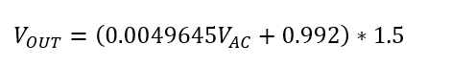

Expression for Current (voltage proportional to current) as seen by FPGA:

Voltage with a sensitivity of 65.7 mV per A with a offset voltage of 1.68V

Power calculation

* Repeat process for 1680 Consecutive times 🡪 occurs every 200 us so one window consists of 200us*1680 = 336 ms
  + Instantenous voltage sample is multiplied by instanenous current sample
  + Previously obtained instantenous power value is added to a running sum
* After 336 ms window, **sum** of instanenous power is transmitted via I2C to the Main Module
* Within main module number is multiplied by 774.2771081*10^-9
$$Main Module Power constant=\left(\frac{{3.3}^{2}}{{4096}^{2}}\right)*\left(\frac{1}{1680}\right)*\left(2004\right)=774*{10}^{-9}$$

* (3.3/4096) corresponds to converting from analog to digital representation of voltage 🡪calculation is squared because power is voltage * current and both voltage and current have been sampled and digitized
* (1/1680) Is used to divide by the time scale. Since measurement is sum of all total measurements, dividing by number of measurements will give average measurement.
* (2004) represents the scaling that is occurring to obtain the voltages seen by the FPGA and is calculated as follows:

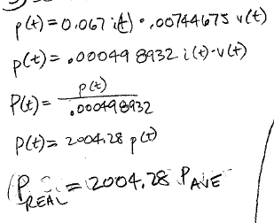

Voltage calculation

* Repeat process for 1680 Consecutive times 🡪 occurs ever 200 us so one window consists of 200us*1680 = 336 ms
  + Instantenous voltage sample is multiplied by instanenous Voltage sample
  + Previously obtained Voltage^2 value is added to a running sum
* After 336 ms window, **sum** of instanenous voltage is transmitted via I2C to the Main Module

Current calculation

* Repeat process for 1680 Consecutive times 🡪 occurs ever 200 us so one window consists of 200us*1680 = 336 ms
  + Instantenous current sample is multiplied by instanenous current sample
  + Previously obtained current^2 value is added to a running sum
* After 336 ms window, **sum** of instanenous current is transmitted via I2C to the Main Module